EXERCISE 4
- List the first and last names of all employees who draw less than or equal to $90000 and are not Programmers, Senior programmers or Multimedia programmers.
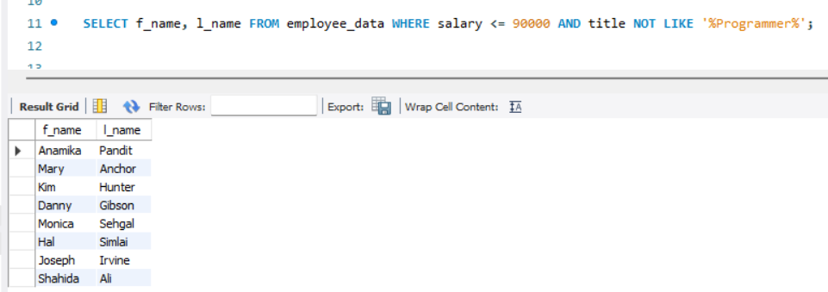
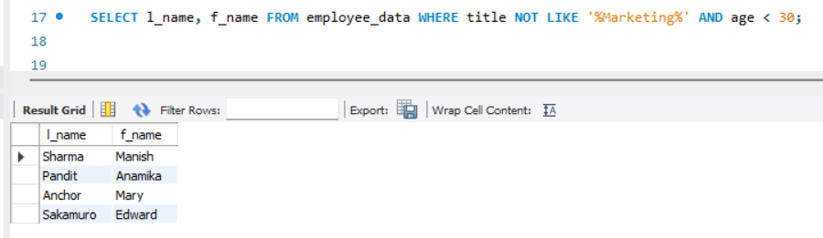
- What is displayed by the following statement?

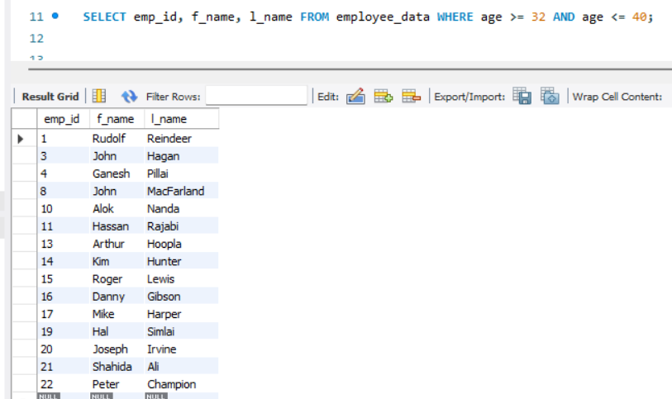
- List all ids and names of all employees between 32 and 40 years of age.

- Select names of all employees who are 32 years of age and are not programmers.
SELECT f_name, l_name FROM employee_data WHERE age = 32 AND title NOT LIKE ‘%Programmer%’;

